**E R Modeling (Entity Relationship Modeling)**

Entity Relationship Model (ER Modeling) is a graphical approach to database design. It is a high-level data model that defines data elements and their relationship for a specified software system. An ER model is used to represent real-world objects.

The ER model describes data as entities, relationships, and attributes.

**Entity**

The basic concept that the ER model represents is an entity, which is a thing or object in the real world with an independent existence.

An entity may be an object with a physical existence (for example, a particular person, car, house, or employee) or it may be an object with a conceptual existence (for instance, a company, a job, or a university course).

**Attributes**

Each entity has attributes.

Attributes are the particular properties that describe entity. For example, an EMPLOYEE entity may be described by the employee’s name, age, address, salary, and job.

Attributes are the properties which define the entity type. For example, Roll_No, Name, DOB, Age, Address, Mobile_No are the attributes which defines entity type Student. In ER diagram, attribute is represented by an oval.

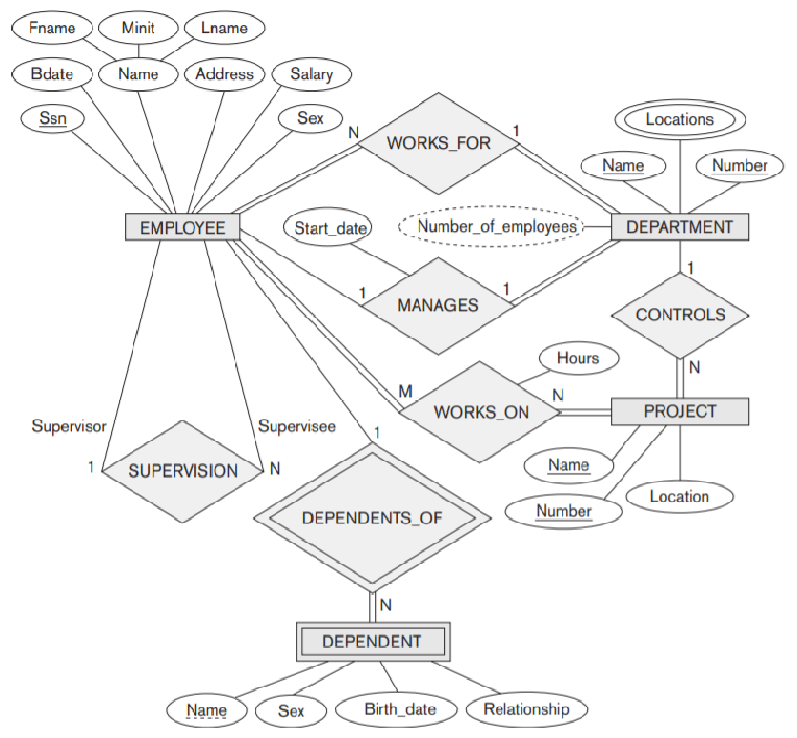



Figure 3.3 shows two entities and the values of their attributes. The EMPLOYEE entity e1 has four attributes: Name, Address, Age, and Home_phone; their values are ‘John Smith,’ ‘2311 Kirby, Houston, Texas 77001’, ‘55’, and ‘713-749-2630’,respectively. The COMPANY entity c1 has three attributes: Name, Headquarters, and President; their values are ‘Sunco Oil’, ‘Houston’, and ‘John Smith’, respectively.

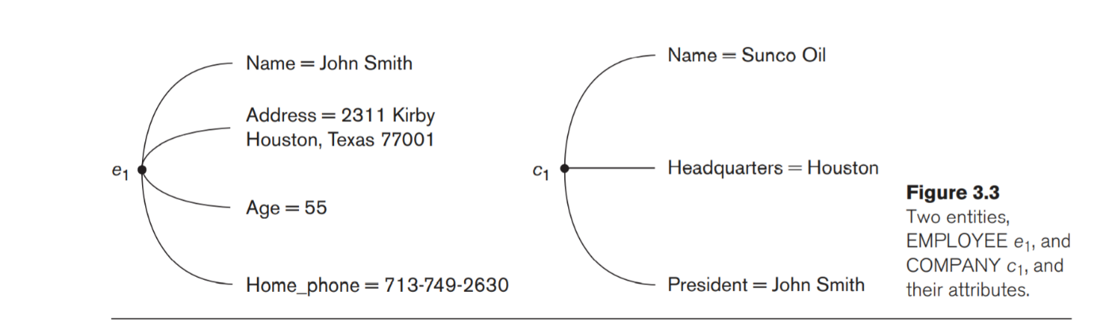

**Several types of attributes occur in the ER model:**

**Composite versus Simple (Atomic) Attributes.** Composite attributes can be divided into smaller subparts, which represent more basic attributes with independent meanings. For example, the Address attribute of the EMPLOYEE entity shown in Figure 3.3 can be subdivided into Street_address, City, State, and Zip, 3 with the values ‘2311 Kirby’, ‘Houston’, ‘Texas’, and ‘77001’.

Attributes that are not divisible are called simple or atomic attributes. Composite attributes can form a hierarchy;for example, Street_address can be further subdivided into three simple component attributes: Number, Street, and Apartment_number, as shown in Figure 3.4.

The value of a composite attribute is the concatenation of the values of its component simple

attributes.

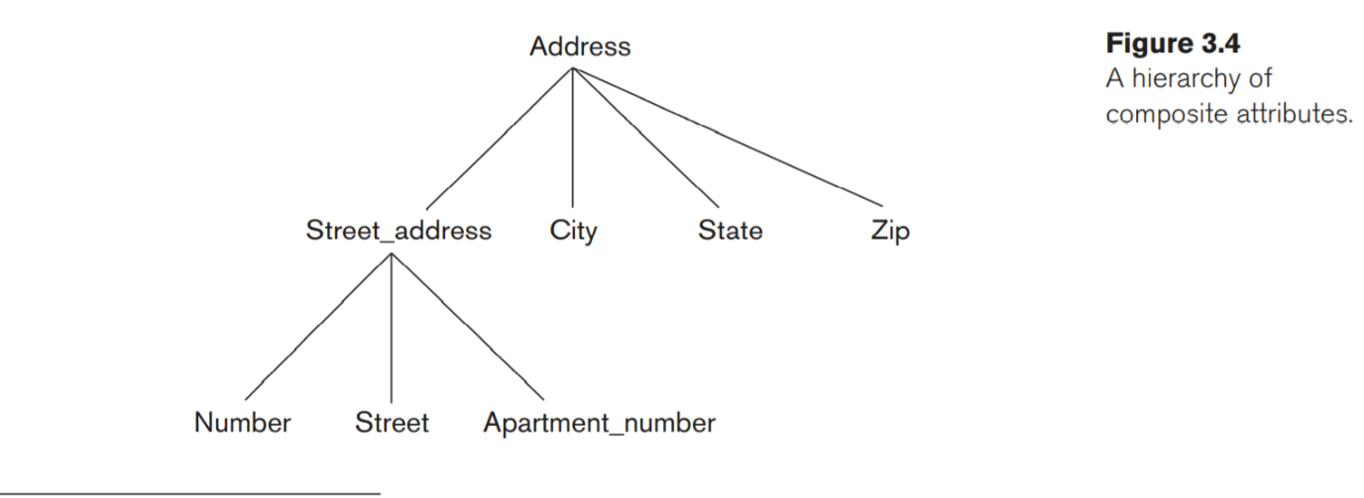

**Single-Valued versus Multivalued Attributes.** Most attributes have a single value for a particular entity; such attributes are called single-valued. For example, Age is a single-valued attribute of a person.

In some cases, an attribute can have a set of values for the same entity—for instance, a Colors attribute for a car, or a College_degrees attribute for a person.

Similarly, one person may not have any college degrees, another person may have one, and a third person may have two or more degrees; therefore, different people can have different numbers of values for the College_degrees attribute. Such attributes are called multivalued.

**Stored versus Derived Attributes.** In some cases, two (or more) attribute values are related—for example, the Age and Birth_date attributes of a person. For a particular person entity, the value of Age can be determined from the current(today’s) date and the value of that person’s Birth_date. The Age attribute is hence called a derived attribute and is said to be derivable from the Birth_date attribute, which is called a stored attribute.

Some attribute values can be derived from related entities; for example, an attribute Number_of_employees of a DEPARTMENT entity can be derived by counting the number of employees related to (working for) that department.

**NULL Valued attributes:** In some cases, a particular entity may not have an applicable value for an attribute. For example, the Apartment_number attribute of an address applies only to addresses that are in apartment buildings and not to other types of residences, such as single-family homes.

Similarly, a College_degrees attribute applies only to people with college degrees. For such situations, a special value called NULL is created.

**Key Attributes:** The attribute which uniquely identifies each entity in the entity set is called key attribute. For example, Roll_No will be unique for each student. In ER diagram, key attribute is represented by an oval with underlying lines.